**Albacora**

**SQS Project**

Albocora tuna company – system for generating tuna sales quotations.

Dashboard + KPI

* Total quotes pending approval
* Total quotes expiring today
* Total quotes expiring this week
* Skipjack fish price size 3
* Yellowfin fish price size 6
* Total approved quotes last month
* Total expired quotes last month
* Total draft quotes
* Quote volume last month
* Quote conversion rate last month
* Average response time last month
* Average quote value last month
* Rejection rate last month
* Pending quotes rate last month
* Approved closure rate last month

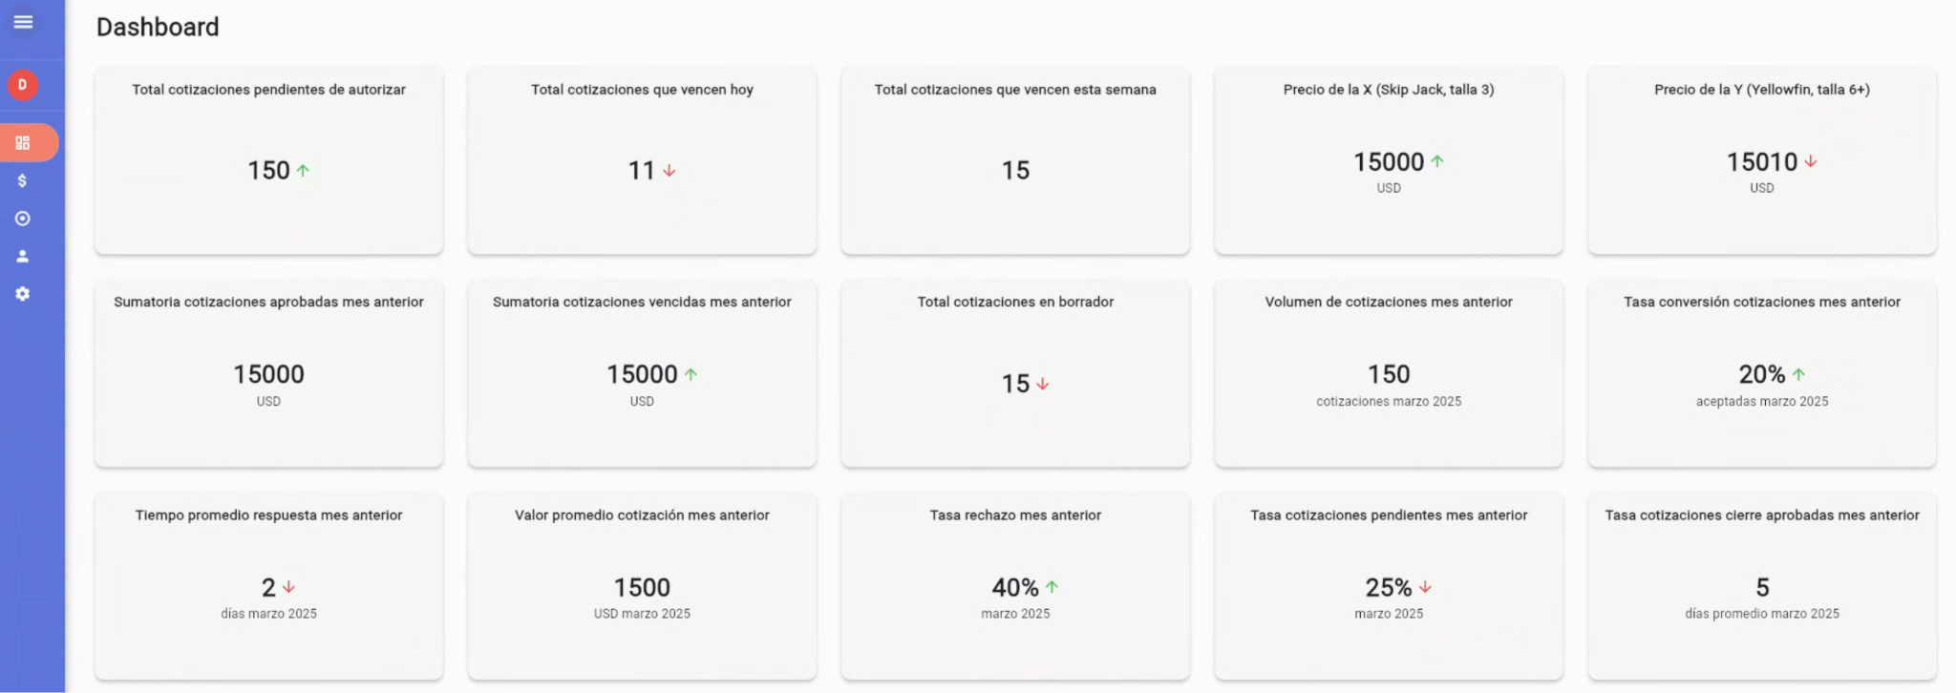

**Newry Global Media**

*ASO Project*

Newry is a marketing company specialized in the development and monetization of mobile applications. Development of an AI for the automatic generation of keywords to improve ASO ranking in the Apple and Google Stores.

Dashboard + KPI

* Total downloads
* Conversion rate
* Average rating
* Errors & Apps at risk
* Total impressions
* Keywords

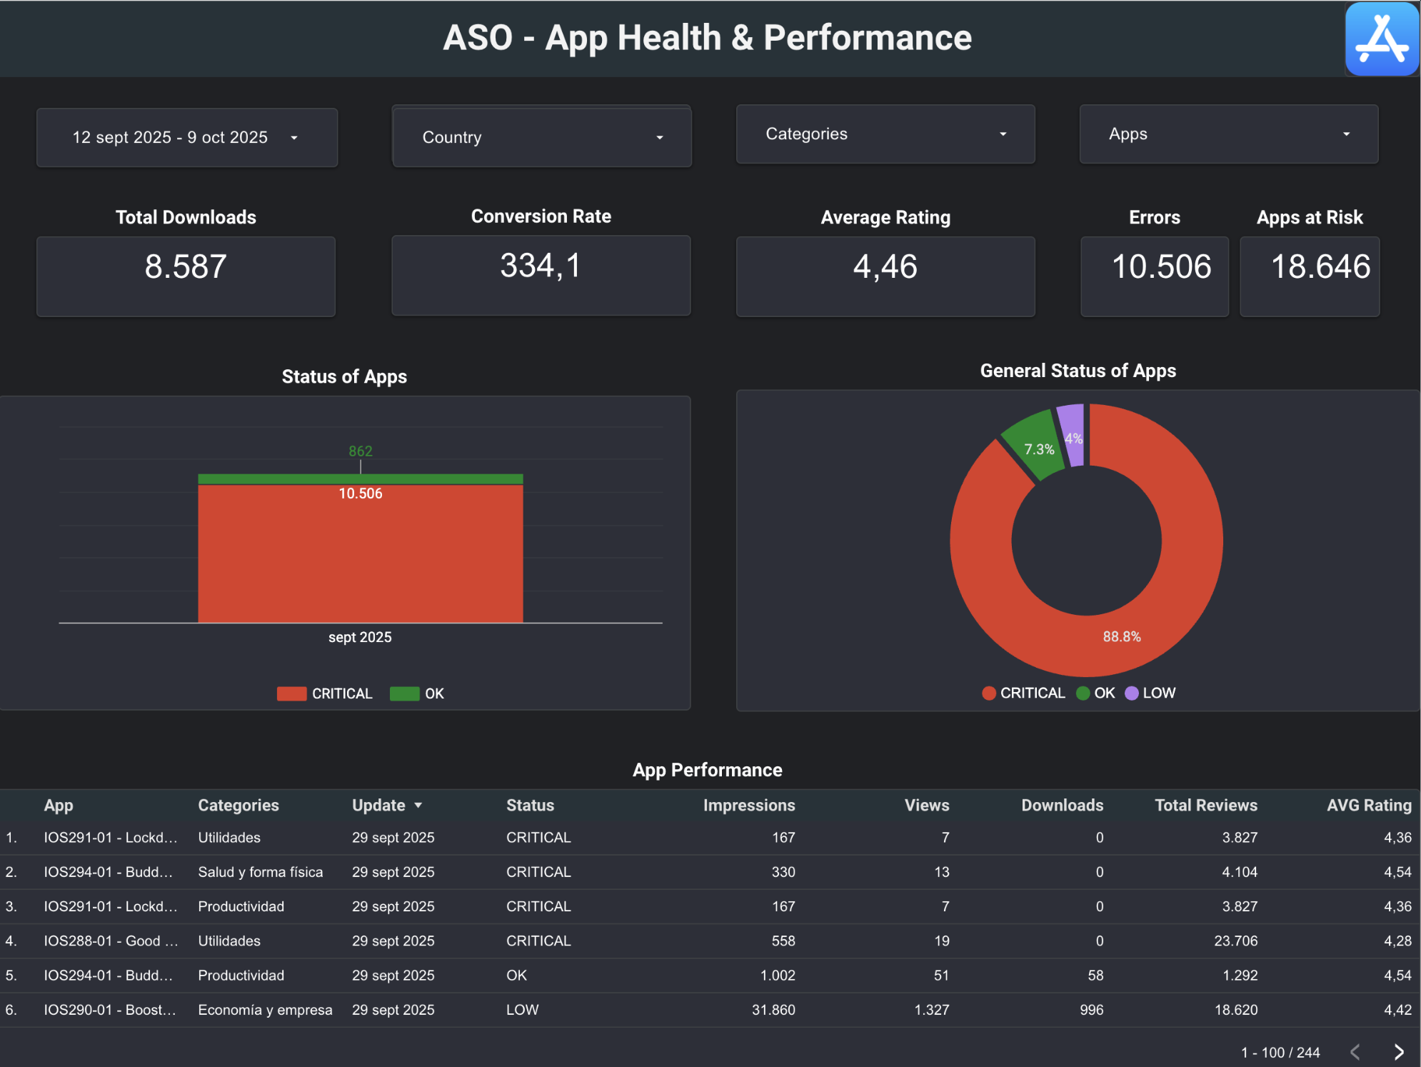

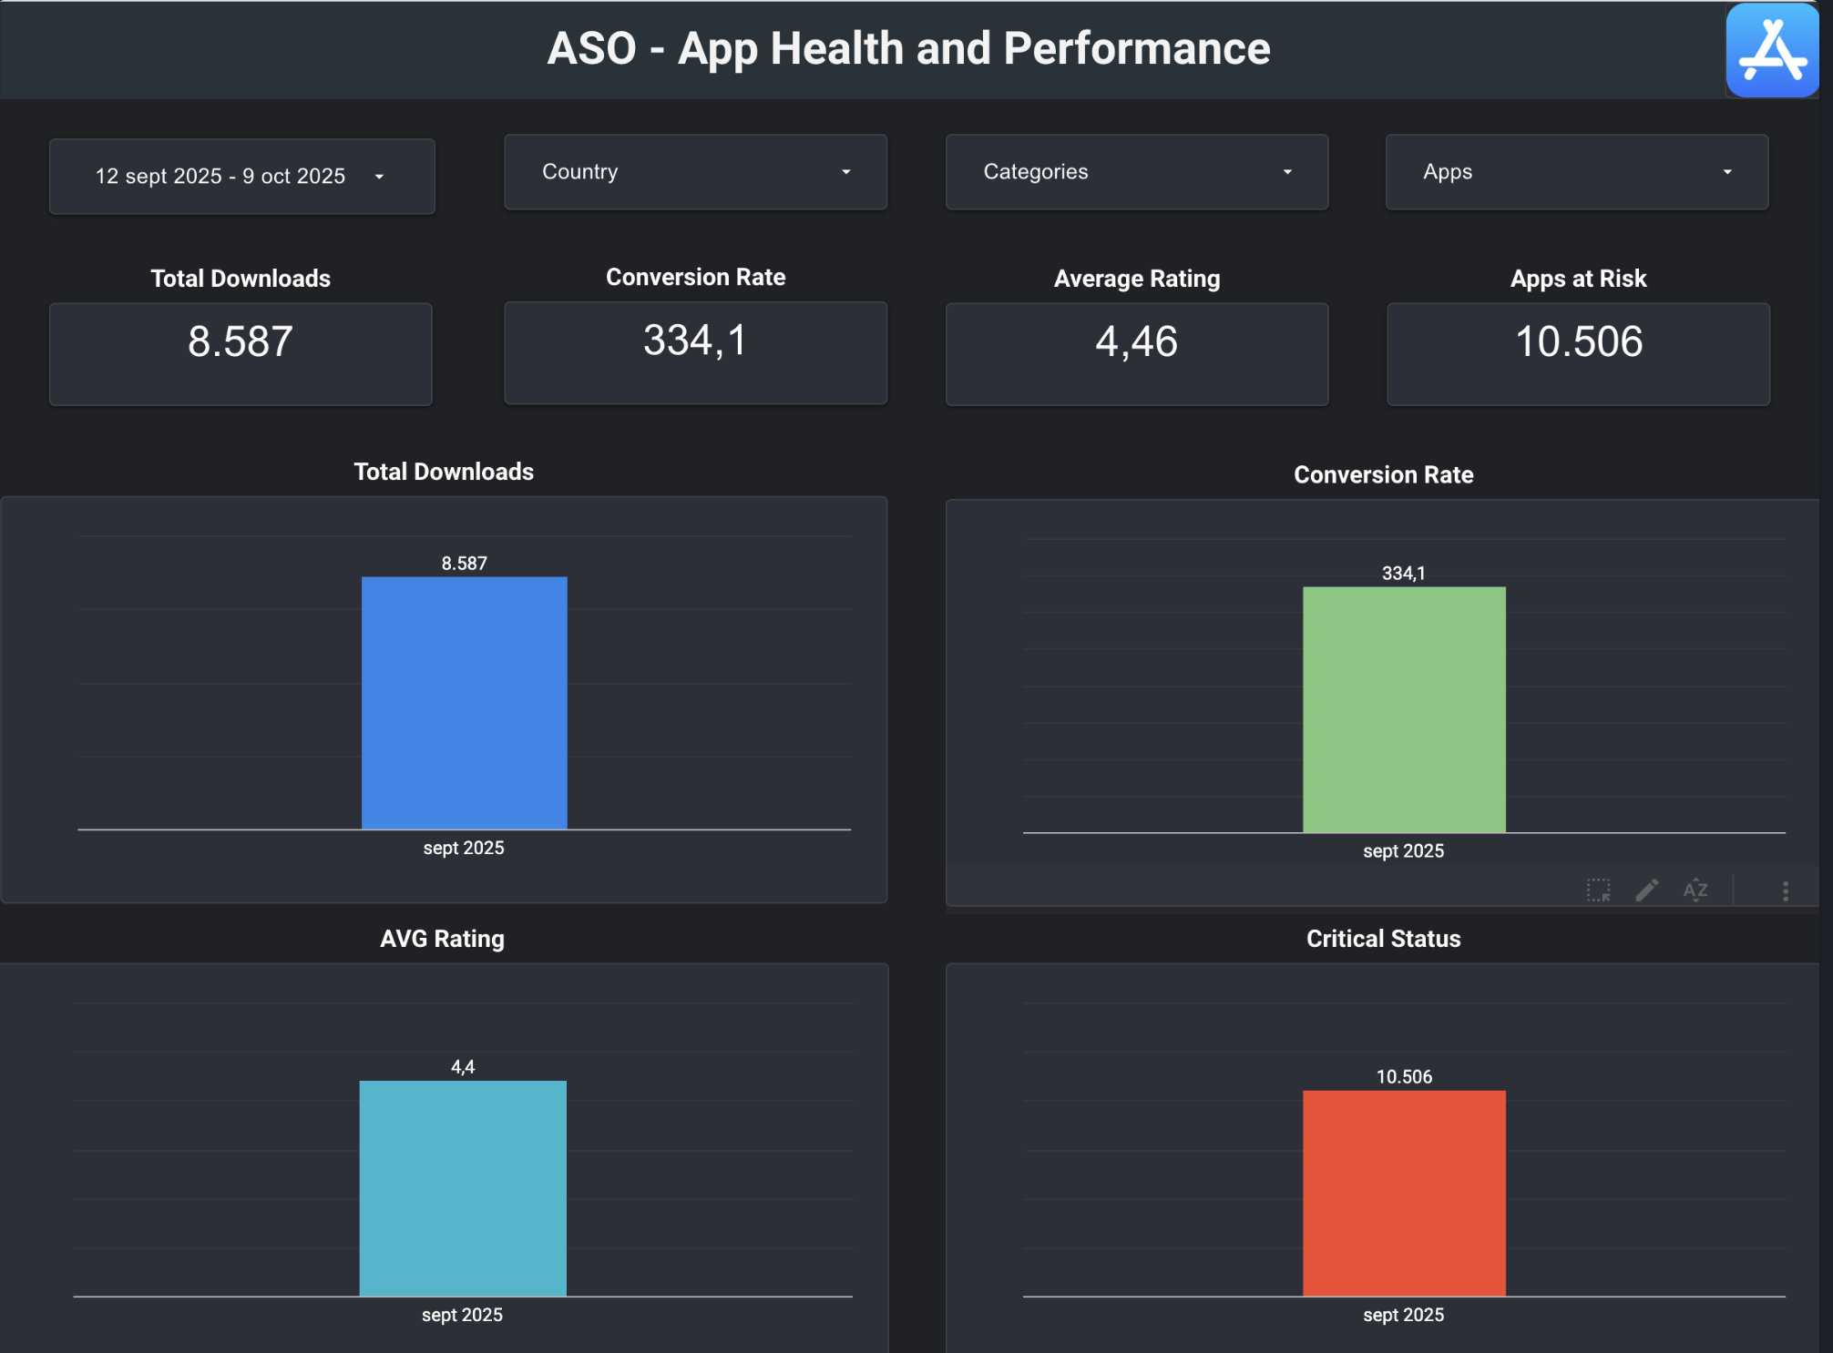

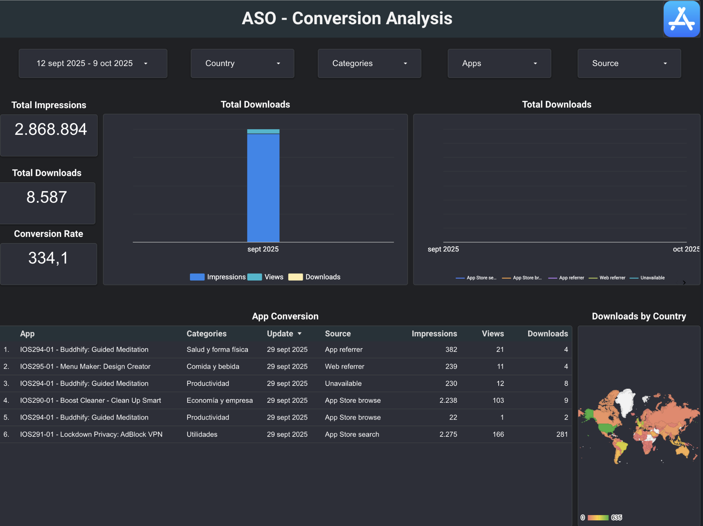

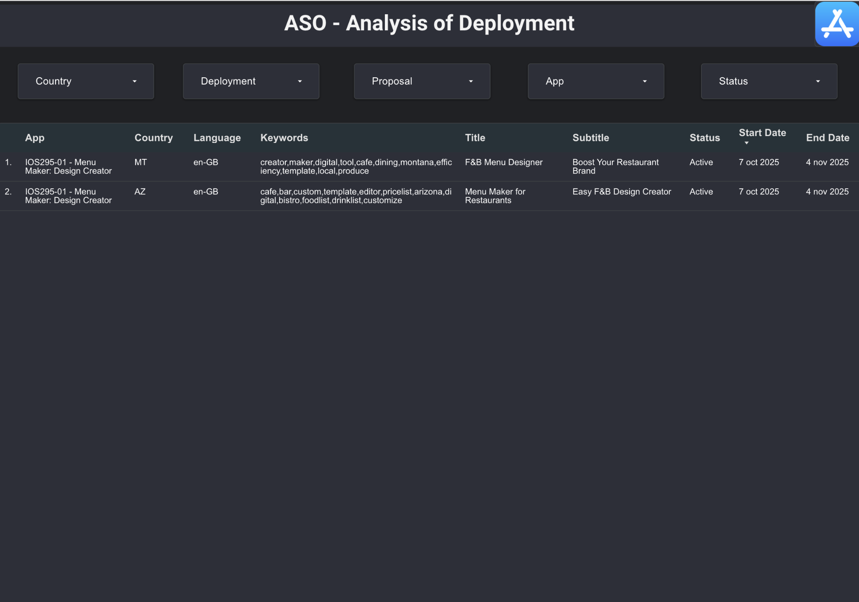

**Función Digital**

***Nomadita***

Boutique Hotel Chatbot for the Riviera Maya POC

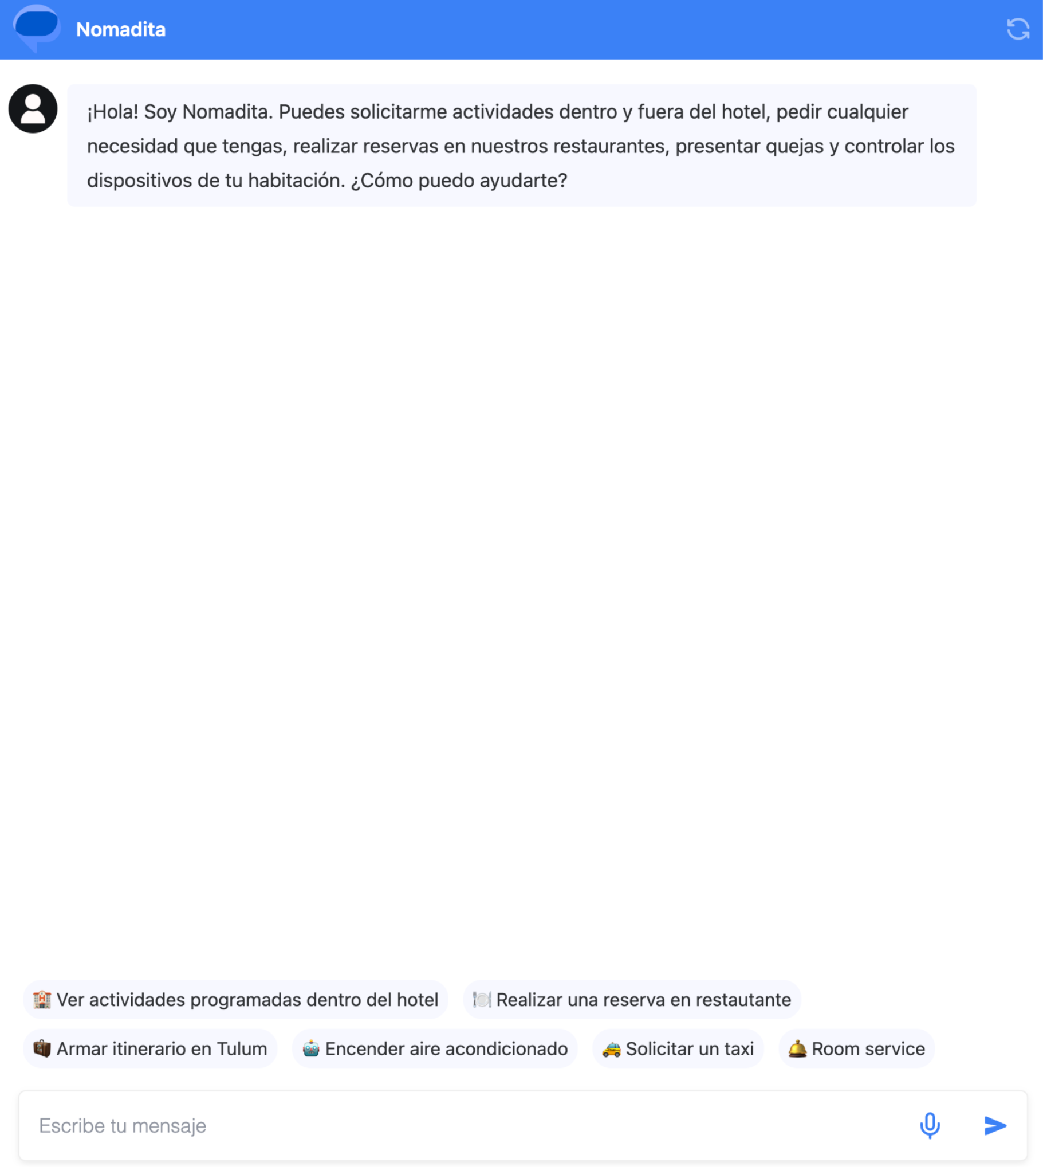

***MiCampus***

University Campus Chatbot POC

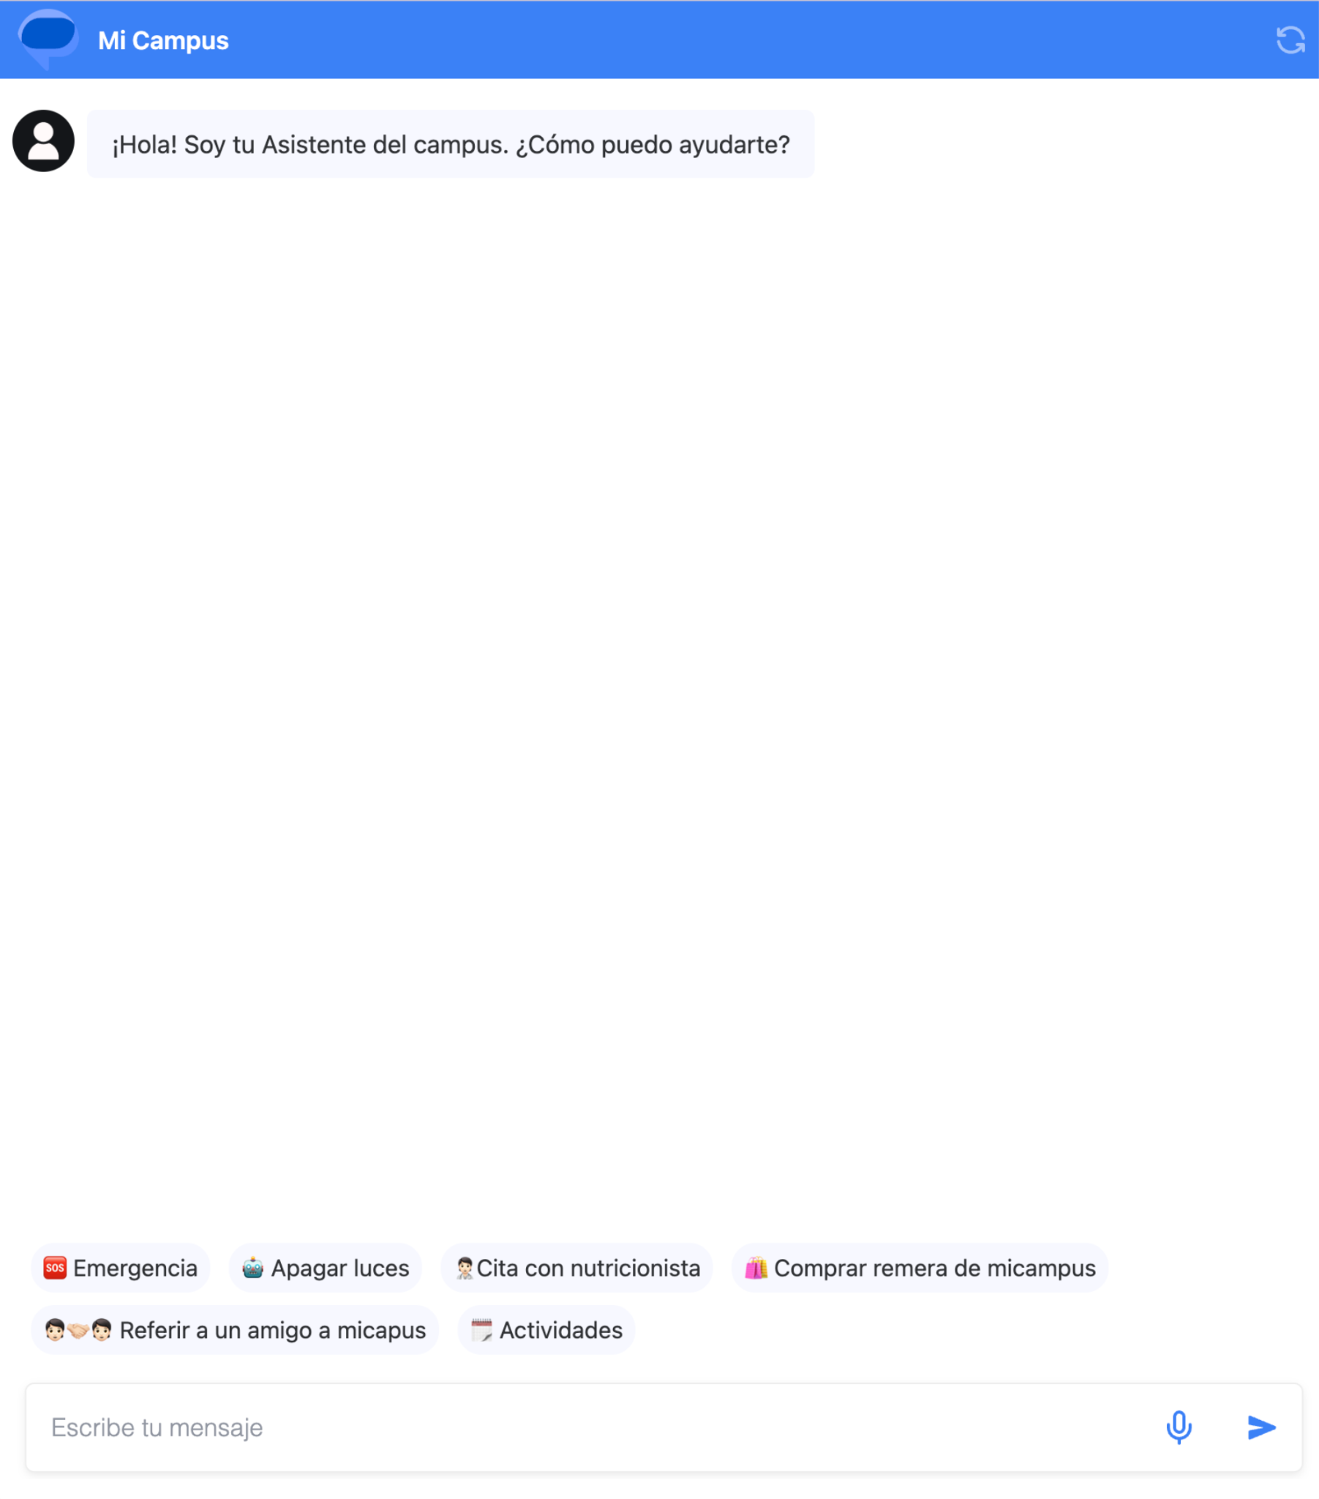

***Vidrios Project***

Data Lake implementation with Snowflake on Azure and Data Analytics using Power BI with SAP.

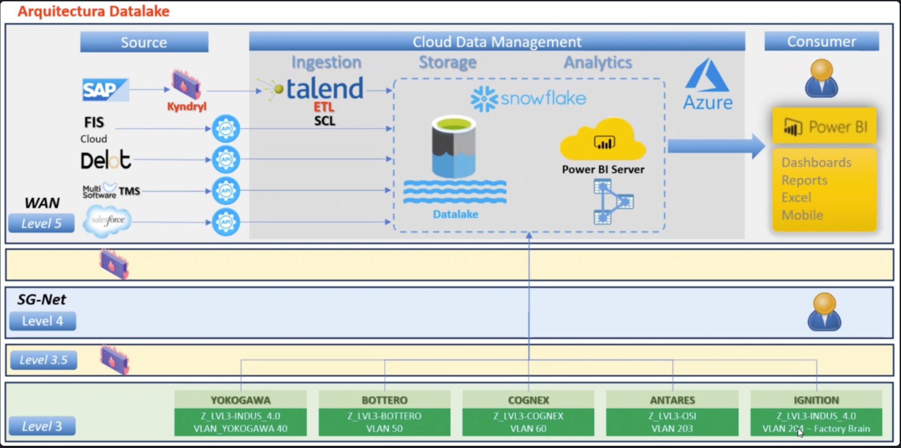

**BERD**

***Grafana Project***

We designed and implemented a complete monitoring and observability platform based on Grafana, delivering centralized visibility and proactive alerting across the entire infrastructure. The solution integrated Prometheus for metrics collection, Mimir for long-term metric storage, Loki for log aggregation, and Alertmanager for notification orchestration.

Metrics were collected across DEV and PROD environments from multiple sources including system resources (Node Exporter), database performance (PostgreSQL Exporter), application metrics (custom Node.js metrics and PM2), and security layers (Fail2Ban and CSF). Dynamic Grafana dashboards were built to monitor applications, infrastructure, and database health in real time from a single unified interface.

The platform also included automated alerts with Slack integration, threshold-based monitoring for CPU, memory, and disk, and performance testing with k6 integrated into Grafana. Security was enforced through NGINX reverse proxy, SSL encryption, credential management, and IP whitelisting. The deployment was fully documented with operational guidelines for maintenance and credential rotation.

This architecture enabled end-to-end observability, improved system reliability, accelerated incident response, and provided a scalable foundation for future monitoring needs.

